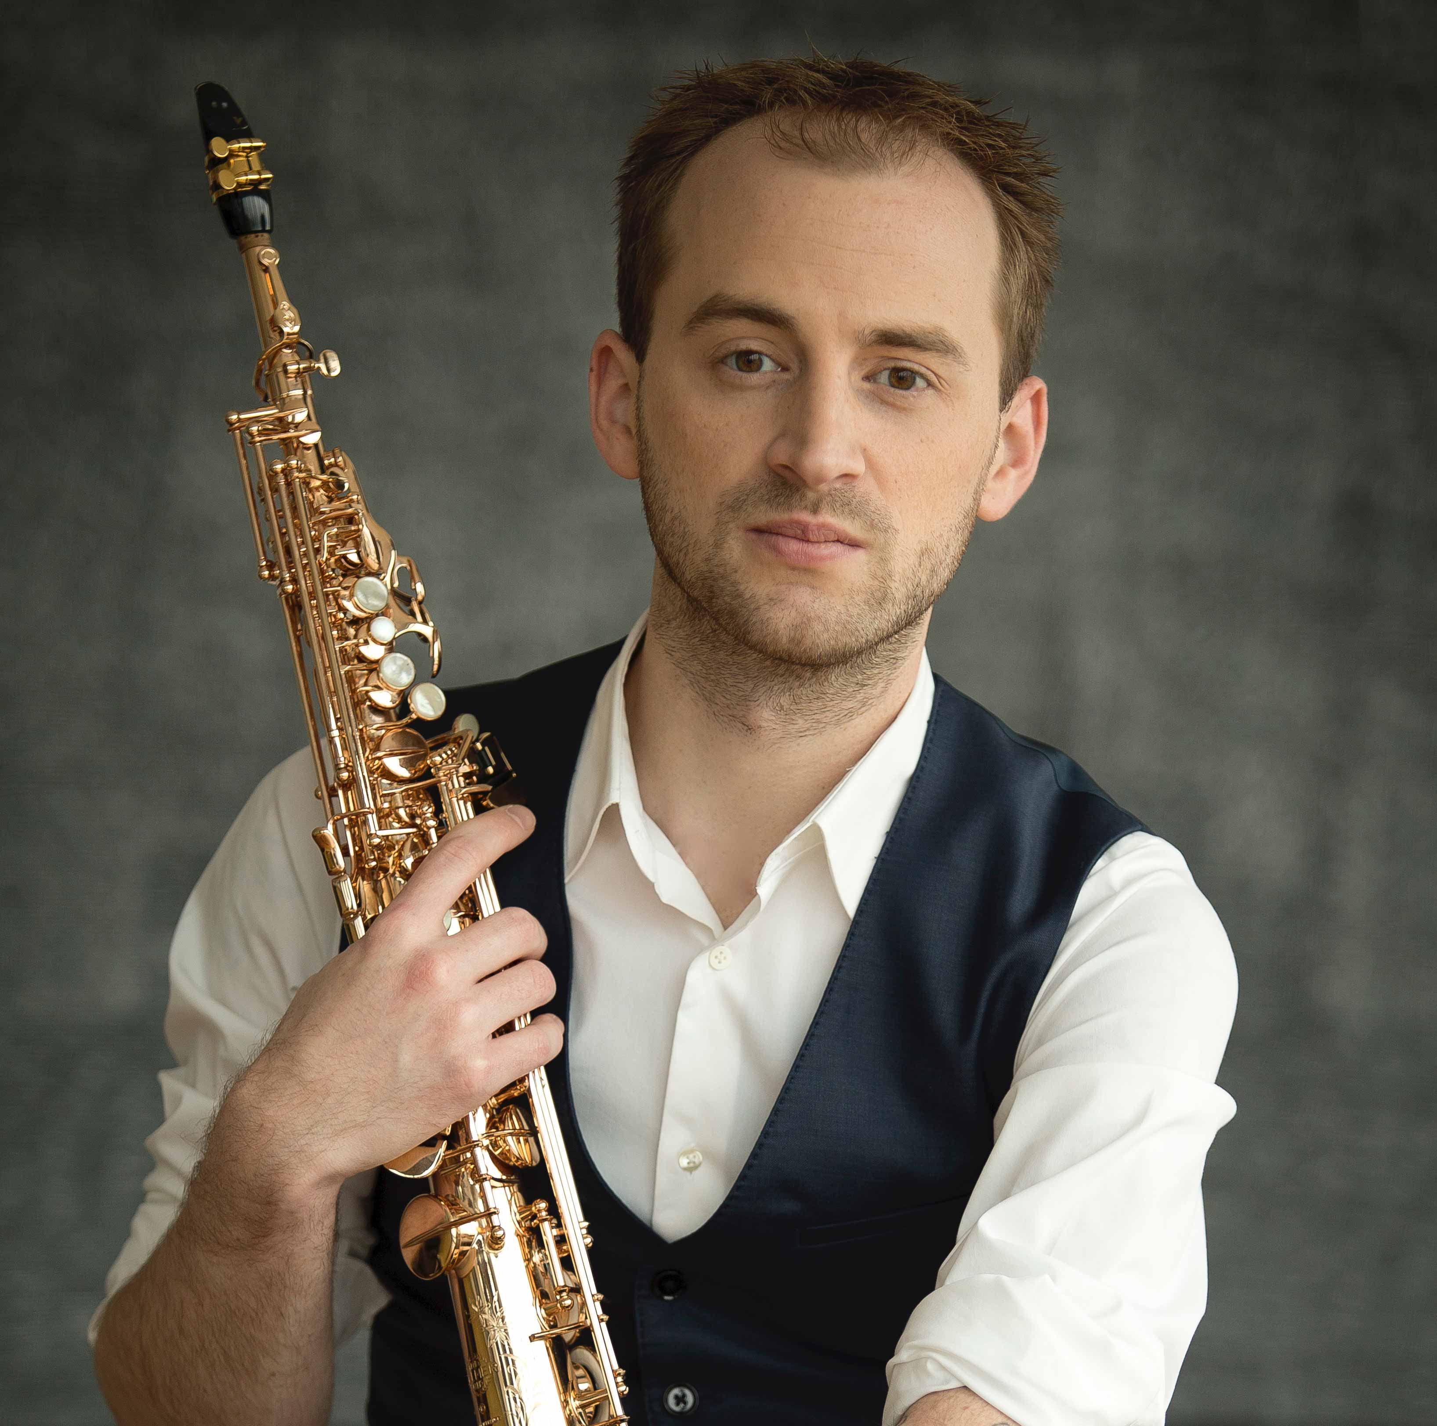
Jonathan Wintringham, concert saxophonist
www.jonathanwintringham.com

“A saxophonist of unusual sophistication”
-Philadelphia Inquirer
“Absolutely stunning…nothing short of a virtuoso”
-The Sax Magazine, Japan
“A major force in the saxophone world”
-American Record Guide

Professional Biography (Full):
“A major force in the saxophone world,” (American Record Guide) internationally acclaimed saxophonist and recording artist Jonathan Wintringham has been described as “absolutely stunning…nothing short of a virtuoso,” (‘The Sax’ Magazine, Japan) and “a saxophonist of unusual sophistication…changing his color in ways so sensitive that he bordered on alchemist” (Philadelphia Inquirer). “Possessing a confidence and grace that comes from somewhere beyond experience,” (Arizona Daily Star) “he phrases with an artistic awareness well beyond his years; and he tackles the postmodernist content of his program with extreme volume shifts [and] daring color changes” (ARG). He is in demand as a performer and educator, leading to engagements throughout the United States, Canada, China, England, Japan, Mexico, and South Korea. Guided by a strong desire to collaborate with living composers, Jonathan has contributed to the addition of over forty new works for saxophone, including projects with composers Martin Bresnick, Michael Djupstrom, Gilad Hochman, Graham Lynch, Marc Mellits, SunYoung Park, Greg Wanamaker, and many more.
As a soloist and chamber musician, Wintringham emerged as a leading performer of his generation through first-place awards in more than twenty competitions, including the Music Teachers National Association (MTNA) National Chamber Music Competition, MTNA National Young Artist Competition, Chamber Music Yellow Springs Competition, Astral Artists National Auditions, Arizona State University Concerto Competition, Tucson Symphony Orchestra Concerto Competition, University of Arizona President’s Concerto Competition, and the Tucson Chamber Orchestra Concerto Competition. In 2015, Wintringham received the S&R Foundation’s Washington Award for “dynamism, vision, and exceptional creativity,” primarily for his artistic efforts on an international scale. As a result of the 2014 Mahler Philharmoniker's International Auditions, Wintringham was selected as the first saxophonist to join the MPhil Artist’s Roster based in Vienna, Austria. Other awards include the 2014 and 2012 North American Saxophone Alliance (NASA) Classical Solo Competitions, the Yamaha Young Performing Artists Competition, and the William C. Byrd Concerto Competition. Additionally, Wintringham was awarded a Performer’s Certificate from the Eastman School of Music for demonstrating “outstanding performing abilities,” as well as Eastman’s John Celentano Award for “excellence in chamber music,” and the Teaching Assistant Prize for “excellence in teaching.”
Wintringham is a highly sought-after performer and educator, leading to recitals, master classes, and residencies at musical institutions worldwide, including the Eastman School of Music, London College of Music (England), Xinghai Conservatory (China), Chongqing Normal University (China), Central Conservatory (China), Shanghai Conservatory (China), Kunitachi College of Music (Japan), Temple University, Arizona State University, the University of Arizona, and more. He was the first featured Artist in Residence at the Zennor Music Series in Cornwall, England, and the first classical saxophonist to be featured on American Public Media's Performance Today: Young Artists in Residence. He was also interviewed and invited to perform for several other television and radio shows including FOX News, WXXI, KLPX, and KUAT Television. Wintringham’s debut CD, Walimai, has been broadcast internationally, including on England’s BBC and Japan’s FMN1, and is available on the Equilibrium (Albany) label.
Wintringham is currently the soprano saxophone chair of the award-winning chamber ensemble, the East End Quartet, whose performances have been described as “deep and powerful, sweet and high, fast and madcap” (SILive). Today, East End is gaining recognition for its unique approach to programming, which features close collaboration with composers, in-house arrangements, and an eclectic range of their own transcriptions. East End will release its debut album in 2022, featuring the music of J.S. Bach, Viet Cuong, Michael Djupstrom, Jun Nagao, Astor Piazzolla, and more. Additionally, Jonathan’s former award-winning chamber ensemble, The Catalina Quartet, can be heard on AUR’s America’s Millennium Tribute to Adolphe Sax, Volume XIV presenting the North American premiere recording of Gavin Bryars’ Alaric I or II. Wintringham further served as a member of several recording and award-winning chamber ensembles including the Presidio Saxophone Quartet, and the saxophone trio, Trikaya.
In addition to his duo with composer and pianist Michael Djupstrom, Wintringham performs regularly as a member of the Bando/Wintringham Duo. Together with Kuninobu Bando, Professor of Saxophone at the Kunitachi College of Music, the Tokyo-based chamber ensemble has received numerous accolades for their international performances since their formation in 2009. The duo’s debut album was released in May 2015 in Tokyo’s Izumi Hall and features world-premiere recordings of music by Ted Goldman, Randall Cornelison, Ken Thomson, and Izumi Matsumoto, as well as the music of Astor Piazzolla and Marc Mellits. The duo’s latest project paired them with trailblazing composer Jonathan Russell and the Eastman Wind Ensemble for the premiere of Russell’s new double-concerto, Fantasy on Five. Commissioned by the duo, the world-premiere took place in the spring of 2016, during the US-based portion of their CD release tour.
Wintringham is a co-founder and the Executive Director of the International Saxophone Academy. He holds a Doctor of Musical Arts degree, a Master of Music degree, and a Performer’s Certificate from the Eastman School of Music. His past instructors include Chien-Kwan Lin, Timothy McAllister, Nobuya Sugawa, Masato Kumoi, Kelland Thomas, Scott Wright, and Asako Inoue. Furthermore, he has performed in master class settings for Vincent David, Claude Delangle, Masataka Hirano, Hitomi Hara, Lars Mlekusch, John Sampen, Kenneth Tse, and James Umble. As a recipient of the University of Arizona’s Undergraduate Research Grant and several Professional Development Grants from the Eastman School of Music, Jonathan performed significant research involving the role of saxophone in Japan, including a six-month Tokyo based investigation into the inner workings of the collegiate training systems and musical cultures of Japan.
Wintringham is a Conn-Selmer Artist and plays Selmer (Paris) saxophones exclusively. He is also an Astral Artists’ Laureate and an Endorsing Artist for MusicMedic’s RooPads.
Professional Biography (500 word):
“A major force in the saxophone world,” (American Record Guide) Jonathan Wintringham has been described as “absolutely stunning…nothing short of a virtuoso,” (‘The Sax’ Magazine, Japan) and “a saxophonist of unusual sophistication…changing his color in ways so sensitive that he bordered on alchemist” (Philadelphia Inquirer). “Possessing a confidence and grace that comes from somewhere beyond experience,” (Arizona Daily Star) “he phrases with an artistic awareness well beyond his years” (ARG). He is in demand as a performer and educator, presenting throughout the United States, Canada, China, England, Japan, Mexico, and South Korea. Guided by a strong desire to collaborate with living composers, Jonathan has contributed to the addition of over forty new works for saxophone.

Emerging as a leading performer of his generation, he won first-place awards in more than twenty competitions, including the MTNA National Chamber Music and Young Artist Competitions, Chamber Music Yellow Springs, Astral Artists, and several professional and collegiate concerto competitions. He received the S&R Foundation’s Washington Award for “dynamism, vision and exceptional creativity;” a Performer’s Certificate from the Eastman School of Music for demonstrating “outstanding performing abilities,” as well as Eastman’s John Celentano Award for “excellence in chamber music,” and the Teaching Assistant Prize for “excellence in teaching;” and he was selected as the first saxophonist to join the MPhil Artist’s Roster based in Vienna, Austria.
Wintringham presents at musical institutions worldwide, including the Eastman School of Music (US), London College of Music (England), Central Conservatory (China), Shanghai Conservatory (China), Kunitachi College of Music (Japan), and more. He was the first Artist in Residence at the Zennor Music Series in Cornwall, England, and the first classical saxophonist to be featured on APM's Performance Today: Young Artists in Residence. He was interviewed and performed for several other television and radio shows, and his debut CD, Walimai, was broadcast internationally, including on England’s BBC and Japan’s FMN1.
In addition to his duo with composer and pianist Michael Djupstrom, Wintringham performs regularly as a member of the Bando/Wintringham Duo, a Tokyo-based chamber ensemble active since its formation in 2009. The duo’s debut album was released in May 2015 in Tokyo’s Izumi Hall, and their latest project paired them with trailblazing composer Jonathan Russell and the Eastman Wind Ensemble for the premiere of Russell’s new double-concerto, Fantasy on Five. He is a founding member of the award-winning chamber ensemble, the East End Quartet, and his former award-winning chamber ensemble, The Catalina Quartet, can be heard commercially on Arizona University Recordings. Wintringham served as a member of additional recording and award-winning ensembles including the Presidio Saxophone Quartet, and the trio, Trikaya.
Wintringham is a co-founder and the Executive Director of the International Saxophone Academy. He holds a Doctor of Musical Arts degree, a Master of Music degree, and a Performer’s Certificate from the Eastman School of Music. His past instructors include Chien-Kwan Lin, Timothy McAllister, Nobuya Sugawa, Masato Kumoi, Kelland Thomas, Scott Wright, and Asako Inoue.
Wintringham is a Conn-Selmer Artist and plays Selmer (Paris) saxophones exclusively. He is also an Astral Artists’ Laureate and an Endorsing Artist for MusicMedic’s RooPads.
Professional Biography (300 word):
“A major force in the saxophone world,” (American Record Guide) Jonathan Wintringham has been described as “absolutely stunning…nothing short of a virtuoso,” (‘The Sax’ Magazine, Japan) and “a saxophonist of unusual sophistication…changing his color in ways so sensitive that he bordered on alchemist” (Philadelphia Inquirer). “Possessing a confidence and grace that comes from somewhere beyond experience,” (Arizona Daily Star) “he phrases with an artistic awareness well beyond his years” (ARG). He is in demand as a performer and educator, presenting throughout North America, China, England, Japan, and South Korea. Guided by a strong desire to collaborate with living composers, Jonathan has contributed to the addition of over forty new works for saxophone.

Emerging as a leading performer of his generation, he won first-place awards in more than twenty competitions. He received the S&R Foundation’s Washington Award for “dynamism, vision and exceptional creativity,” three awards from the Eastman School of Music for demonstrating “outstanding performing abilities,” “excellence in chamber music,” and “excellence in teaching,” and he was selected as the first saxophonist to join the MPhil Artist’s Roster based in Vienna, Austria. Wintringham presents at musical institutions worldwide, including the Eastman School of Music (US), London College of Music (England), Central Conservatory (China), Shanghai Conservatory (China), Kunitachi College of Music (Japan), and more. He was the first Artist in Residence at the Zennor Music (England), and the first classical saxophonist to be featured on APM's Performance Today: Young Artists in Residence. He was interviewed and performed for several other television and radio shows, and his debut CD, Walimai, was broadcast internationally.

Wintringham is the Co-Founder & Executive Director of the International Saxophone Academy. He holds a Doctor of Musical Arts degree, Master of Music degree, and a Performer’s Certificate from the Eastman School of Music, and his past instructors include Chien-Kwan Lin, Timothy McAllister, Nobuya Sugawa, Masato Kumoi, Kelland Thomas, Scott Wright, and Asako Inoue.
Wintringham is a Conn-Selmer Artist and plays Selmer (Paris) saxophones exclusively. He is also an Astral Artists’ Laureate and an Endorsing Artist for MusicMedic’s RooPads.

Professional Biography (100 word):

“A major force in the saxophone world,” (American Record Guide) Jonathan Wintringham has been described as “absolutely stunning…nothing short of a virtuoso,” (‘The Sax’ Magazine, Japan) and “a saxophonist of unusual sophistication” (Philadelphia Inquirer). He is in demand as a performer and educator throughout the world, and through composer collaborations has contributed to over forty new works for saxophone. A leading performer of his generation, he won awards in more than thirty competitions and was selected as the first saxophonist to join the MPhil Artist’s Roster (Austria), and the first classical saxophonist to be featured on APM's Performance Today: Young Artists in Residence.

Wintringham is the Co-Founder/Executive Director of the International Saxophone Academy. He holds a Doctor of Musical Arts degree, Master of Music degree, and a Performer’s Certificate from the Eastman School of Music.
Wintringham is a Conn-Selmer Artist and plays Selmer (Paris) saxophones exclusively. He is also an Astral Artists’ Laureate and an Endorsing Artist for MusicMedic’s RooPads.

